2026 JC2 H2 GEOGRAPHY Preliminary Examination
Paper 2 Suggested Answers

1a) Strengths: Clearly identifies the target group (Jalan Besar residents) and study location (City Square Mall).

Limitations: “Effective” is subjective and difficult to measure consistently, and the hypothesis is not time-bound.

1b) City Square Mall is a suitable investigation site because it:

Is highly accessible by public transport (nearby bus stops and Farrer Park MRT).

Is close to Jalan Besar residents, increasing the likelihood of obtaining relevant respondents.

Has a strong sustainability focus as an eco-mall, making it relevant for investigating the effectiveness of resource-conservation features.

1c) Students can minimise the impacts of their investigation by:

Disposing of waste properly to avoid littering and pollution.

Respecting respondents and not pressuring unwilling shoppers to participate.

Avoiding surveys inside the mall if they could disrupt businesses.

1d) Strengths

Age ranges instead of exact age: Less sensitive and facilitates comparison between age groups.

No neutral Likert option: Encourages respondents to express a clear opinion, providing richer data.

Weaknesses

Annual income is open-ended: Too sensitive, potentially discouraging responses and reducing sample size.

Green Roof is not explained: Respondents may lack sufficient knowledge, reducing response reliability.

Insufficient space for explanations: Limits respondents’ ability to justify their answers.

1e)
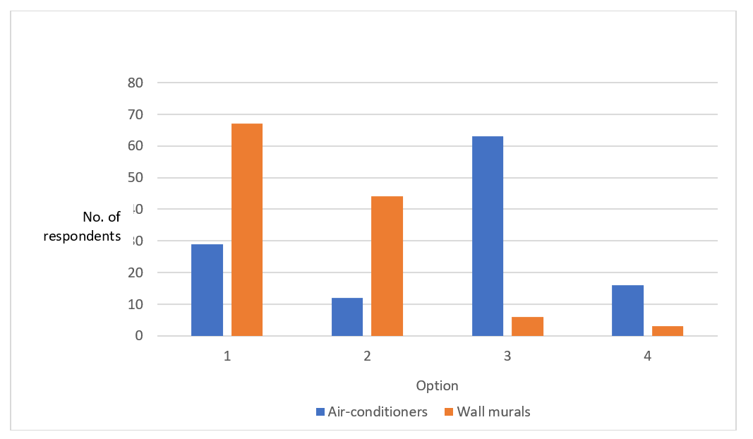

Better visual comparison: Differences in respondent numbers are more clearly shown by differences in bar height.

1f) A pilot survey would help students:
- Test and refine survey questions to reduce confusion and improve responses.
- Build confidence and fieldwork experience, improving respondent recruitment.
- Become familiar with the study site, allowing more efficient fieldwork.

1g) The conclusion has some validity, but significant methodological weaknesses limit its reliability.
- Most respondents rated 5 of 7 mall features as effective, based on a reasonably large sample (120 respondents) across different age groups.
- The wall murals and Green Roof were rated ineffective by most respondents, so effectiveness was not consistent across all features.
- The survey did not verify whether respondents were actually Jalan Besar residents.
- Data were collected only on two Sundays during the June holidays.
- Convenience sampling and surveying at City Green may have overrepresented particular age groups; stratified sampling would be more representative.
- The conclusion is partially supported, but its validity is substantially weakened by sampling, timing, location and questionnaire-design issues.

2a) All four countries reduced their fossil-fuel energy shares from 1965–2021, but by different amounts.
- Largest decline: Iceland (75% → 11%), followed by France (89% → 49%) and the UK (98% → 76%).
- Smallest decline: Japan (90% → 85%), with a notable temporary increase after 2011.
- By 2021: Japan remained most fossil-fuel dependent, while Iceland was least dependent.

2b) Burning fossil fuels: Releases stored carbon as CO₂, increasing greenhouse gas concentrations → more outgoing longwave radiation is absorbed and re-radiated back to Earth → enhanced greenhouse effect.
Deforestation: Reduces vegetation acting as a carbon sink → less CO₂ removed through photosynthesis → higher atmospheric CO₂ → greater heat retention.
•

2c) Climate change is projected to cause a net loss in global plant species richness, but impacts vary spatially.
Greatest losses (10–15%): Mainly tropical regions, especially the Amazon Basin and southern Africa; none reaches the highest 20% category.
Moderate losses (5–10%): Parts of the USA, central Africa, southern Australia and Southeast Asia.
Low losses/slight gains: Limited areas of North America, western Europe and central Russia.
Greenland: No data indicated.

2d) Food security: Reduced plant diversity decreases crops, wild foods and genetic resources available for agriculture.
Livelihoods: Threatens communities dependent on agriculture, forestry and ecotourism.
Ecosystem services: Weakens carbon storage, soil protection and water regulation, increasing environmental risks.
Declining plant diversity threatens human well-being by reducing ecosystem services, livelihoods and future biological resources.

2e) Overall climate finance increased from about US$54b (2013) to US$79b (2019), despite a mid-period dip and missing 2015 data.
- Mitigation: Largest share throughout; increased from ~US$40b to US$50b.
- Adaptation: Smaller but grew steadily from ~US$8b to US$20b.
- Cross-cutting: Smallest category; gradually increased from ~US$4b to US$8b.

2f) Global cooperation is difficult because developing countries remain dependent on fossil fuels and may lack the financial and technological capacity to decarbonise.
Geopolitical challenges: Changes in national policies can weaken international climate agreements and collective mitigation efforts.
Advantages of adaptation: Adaptation can be implemented locally and independently, producing more immediate and direct protection from climate hazards.
Growing necessity: Climate impacts are already occurring and increasingly unavoidable, making adaptation essential.

- ‘The creation of liveable cities for the elderly should focus on their social well-being.’ Evaluate this statement. [20]

Possible Points of Discussion:
Making cities liveable for the elderly requires a holistic approach addressing social, psychological and economic well-being, rather than focusing on social needs alone.
- Social well-being: Retirement, reduced mobility and loss of family/peers can increase loneliness and isolation. Age-friendly transport, accessible infrastructure, community spaces and programmes can promote social interaction and belonging.
- Psychological well-being: Social isolation can undermine purpose, self-worth and cognitive health. Befriending services and continued social participation provide emotional support and mental stimulation.
- Economic well-being: Elderly people need sufficient income for daily needs and healthcare, especially amid rising living costs. Age-friendly employment, retraining and protection against age discrimination can strengthen financial security.
- Elderly liveability should not prioritise social well-being alone; cities need to address social inclusion, psychological health and economic security together to support successful ageing.

- Evaluate the factors that cause the impacts of contemporary climate change to vary between different groups of people. [20]

Possible Points of Discussion:
Climate change affects groups unevenly because of differences in physical exposure, adaptive capacity and demographic vulnerability, with socio-economic conditions often being the most significant.
- Spatial variations: Location determines exposure to different hazards:
  - E.g. Low-lying coasts: sea-level rise, flooding, erosion and saltwater intrusion.
- Adaptive capacity: Wealthier countries and groups have greater access to technology, infrastructure, healthcare, insurance and disaster management, reducing impacts. Poorer populations have fewer resources to adapt and recover, making them disproportionately vulnerable.
- Demographic differences: Vulnerability also varies with age, health, occupation and gender. Children, the elderly, those with health conditions and outdoor workers may face greater risks.
Levels marked:

